- Purpose

To establish a procedure to evaluate and test the 1282-1016 Conductive Glass Assembly.

- Scope
This procedure applies to operations personnel, quality assurance personnel and supervision that are responsible for the testing of the Conductive Glass Assembly.

- Responsibilities
User | - Complies with the policy and procedure.  - Ensures the most current version of this document is used when referenced.
Departmental Management | - Ensures departmental personnel are properly trained before using this policy or procedure.
Quality Assurance | - Performs inspection of all documentation created to ensure that Conductive Glass Assemblies meet the release criteria.  - Releases Conductive Glass Assemblies to inventory for use.

- Equipment
ClearView device, housing cover assembly removed
Computer running ClearView software
Electrode fixture
Test camera, plugged into control board
Timer
Voltage divider
Suction cup

- Procedure - Glass Assembly Visual Inspection and Performance Test
Record results in Test Record

  - Ensure the work area is clean and free of dust.
  - Clean the suction cup with alcohol-soaked lint-free wipe.
  - Obtain glass assemblies for test.
  - Record the glass assembly serial number and lot number.
  - Carefully unfold packaging around glass assembly, being careful not to touch glass, handling only through the packaging or if using nitrile, powder free gloves, only touch the glass edges. From a viewing distance between 6 to 12 inches, inspect both sides of glass assembly for film, scratches, occlusions, streaks or lines that may indicate damage to the ITO coating or lamination, or smudges/fingerprints, or excessive dust. Record Pass (no defects detected) or Fail (defects detected).
  - Segregate acceptable and rejected material. Label rejected glass assemblies as “Fail” indicating the part number, revision level, lot number and serial number(s). Initial and date any labeling generated. Generate a Non-conforming Material Report for all rejected material. Only acceptable glass assemblies will continue to be tested.

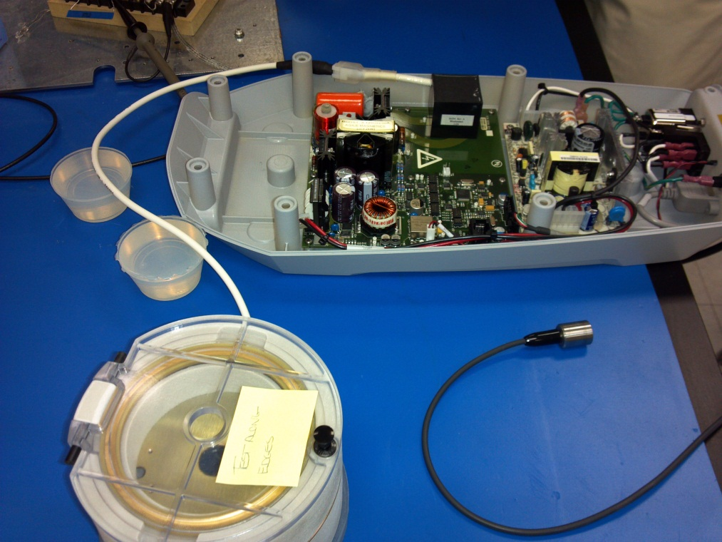
Figure 1

  - Set up computer, device base with camera plugged in, electrode fixture and related tools in a room which can be darkened. Connect wire from electrode fixture to device HV wire. Place fixture and insulators as shown in Figure 1.
  - Using suction cup, place glass into electrode fixture and close lid. Place calibration probe through electrode fixture lid and onto glass.
  - Log into ClearView software and using the Device Testing tab under Settings, connect to the device and set the Boost Voltage to 100% Power.
  - Prepare a timer, place the cursor over the Start Duty Cycle button, and turn off the room lighting.
  - While watching the point where the calibration probe contacts the glass, click the Start Duty Cycle button and start the timer. During the duty cycle operation, observe the conductive glass for proper operation and normal corona formation (example shown in Fig. 2) or failure, seen as streaks of light or sparks in random patterns across the glass (example shown in Fig. 3). If streaks or sparks appear outside of the normal corona, stop the test. Remove the glass, repackage and mark as Failed. If no abnormalities appear, continue the test for three (3) minutes, then click the Stop Duty Cycle button. Record the results of this test in the appropriate location on the Record.

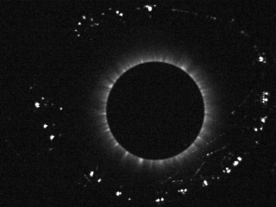
Figure 2 – Normal Corona Figure 3 – Failure

  - If failure is observed, the test is concluded and the glass assembly is labeled Failed indicating the part number, revision level, lot number and serial number(s). Initial and date any labeling generated. Generate a Non-conforming Material Report for all rejected material. If no failure is observed, continue testing in the next steps.
  - Set the Boost Voltage to 120% power. Prepare a timer and place the cursor over the Start Duty Cycle button.
  - While watching the point where the calibration probe contacts the glass, click the Start Duty Cycle button and start the timer. During the duty cycle operation, observe the conductive glass for proper operation and normal corona formation (example shown in Fig. 2) or failure, seen as streaks of light or sparks in random patterns across the glass (example shown in Fig. 3). If streaks or sparks appear outside of the normal corona, stop the test. Remove the glass, repackage and mark as Failed. If no abnormalities appear, continue test for five (5) minutes, then click the Stop Duty Cycle button. Remove the glass, repackage and mark as Passed. Record the results of this test in the appropriate location on the Record.
  - If failure is observed, the test is concluded and the glass assembly is labeled “Fail” indicating the part number, revision level, lot number and serial number(s). Initial and date any labeling generated. Generate a Non-conforming Material Report for all rejected material. If no failure is observed, continue testing in the next steps.

- High Voltage Measurement Test
Record results in Test Record

Reference Figure 4 and 5.
  - Connect the electrode test fixture to the 2.5K Ohm resistor and voltage divider.
  - Connect the oscilloscope to the voltage divider and to ground.

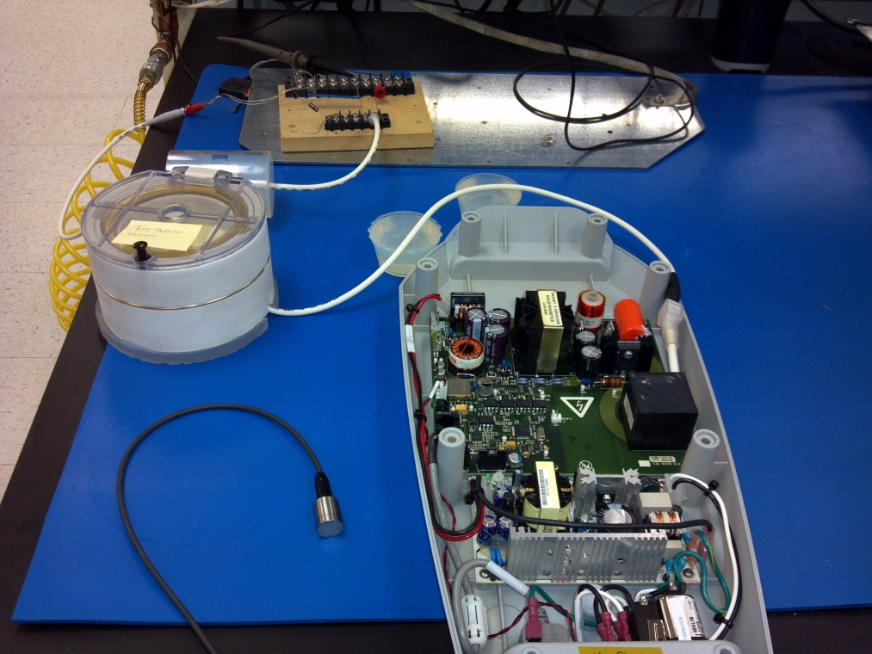
Figure 4
Figure 5

  - Log into ClearView software and using the Device Testing tab under Settings,
connect to the device and set the Boost Voltage to 100% or 110%.
  - Click Begin Exposure to energize the glass. Record the voltage measured for each glass assembly. Passing values are between 9 kV and 15 kV. Record the results of this test in the appropriate location on the Record.
  - If failure is observed, the test is concluded and the glass assembly is labeled “Fail” indicating the part number, revision level, lot number and serial number(s). Initial and date any labeling generated. Generate a Non-conforming Material Report for all rejected material.
  - Label all accepted assemblies indicating those as “Pass” include the part number, revision level, the lot number, and serial number(s). Initial and Date any labeling generated. Forward all glass assemblies, segregating those acceptable and rejected, to QA for documentation review.

- QA Documentation Review and Release

  - QA will review all documentation for completeness and accuracy. Good manufacturing record keeping must be observed (i.e., corrections made with one line through incorrect information and initials and date, full signatures where required, all information legible, all required information recorded and blank spaces recorded N/A or crossed through).
  - QA will ensure that only glass assemblies that meet all inspection criteria will be forwarded to inventory/manufacturing for use in device assembly. Record results of QA inspection in the space provided and sign and date the Glass Assembly Test Record. Ensure that assembly packaging is properly labeled with an Acceptable label as identified in section 6.1.9 of the Inspection and Release of incoming, In-process and Finished Devices and Other Materials procedure. QA will file the Glass Assembly Test Records.
  - Review any Non-conforming Material Reports generated ensuring that the information is complete and accurate and that all assembly packaging is properly labeled with a Rejected label as identified in section 6.1.11 of the Inspection and Release of incoming, In-process and Finished Devices and Other Materials procedure. QA will file the Glass Assembly Test Records.
  - Place all material in quarantine for MRB review.
  - Forward all accepted materials to inventory for storage.

- Reference
06717, Electrode Fixture
QA-016, Inspection and Release of Incoming, In-process and Finished Devices and Other Materials
QA-017, Non-conforming Material
QAF-011, Non-conforming Material Report
QAF-017, Conductive Glass Assembly Visual Inspection and Performance Record
QAF-018, Conductive Glass Assembly High Voltage Test Record
QAF-019, Conductive Glass Assembly QA Inspection Record

- Attachments

None

Document Revision History
Change Order: Number: | Version Number: | Description of Change: | Date: | Updated by:
CC-130221-01 | 000 | New Document | 2/22/13 | D. Miller

